Abstract title (sample)
F. Author¹ and S. Author²
¹Institute, Town, Country
² Another Institute, another town, another country
E-mail: name@mymail.cy

The abstract should be headed by a title, author name(s) and complete address(es) of the author(s). Please underline the name of the author who will present the paper and leave a 3.0 cm margin on top and 2.5 cm margin on all other sides. As font you should use Arial (or Helvetica, or Times New Roman), 12pt with a line spacing of 16pt. The abstract can contain Figures, Tables and References, but the length of the abstract should not exceed one DIN A4 page. Please note that coloured abstracts will be converted to black-and-white.

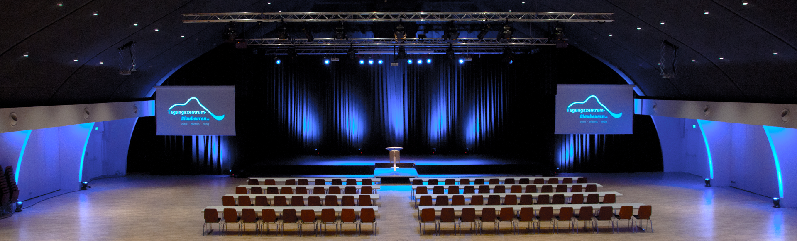
Figure 1: The Conference Venue of the 1st Symposium on Magnesium Batteries.

References

- Author1, Initials; Author2, Initials. Article Title. Journal Abbreviation. Year, Volume, Page numbers.
- Author, F.; Author, S. The Influence of Sweater Vests on Teaching Chemistry. J. Chem. Educ. 2007, 99, 2734-2741.

